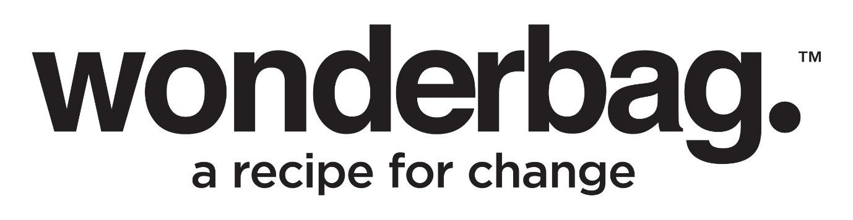

*Press Release*

*For Immediate distribution*

**The Perfect Festive Season Gift for Food, Family, and Sustainability**

With the holiday season approaching, gifting ideas are becoming a top consideration for many – especially with the likes of Black Friday also nearing. While the temptation of fast fashion and international online retailers is strong due to their affordability, how much thought is being given to sustainable gifts that offer lasting value? Fortunately, South Africans needn’t look too far to find something that ticks these boxes, with locally manufactured Wonderbags being readily available online and in select retail stores.

This award-winning, innovative, non-electric slow cooker is perfect for the home cook, the traveller, or anyone who loves to prepare and share a meal. Wonderbag is a unique and thoughtful gift that brings people together while supporting a sustainable future. It is more than just a cooking accessory, because each Wonderbag gives back, especially to the environment and humanitarian causes. For every Wonderbag bought and used, it helps reduce carbon emissions and saves water, contributing to a greener, more sustainable planet. By choosing a Wonderbag, you will also support Wonderbag Foundation initiatives that support the empowerment of women in rural communities where Wonderbags have the biggest impact and create safer cooking conditions and employment opportunities.

Apart from being an ideal gift this festive season, Wonderbag’s innovative design makes it an essential holiday helper. Simply bring your dish to the boil, place it in the Wonderbag, and let it slow-cook to perfection without any additional energy. Not only does it free up stove space for other dishes, but it also allows for effortless, flavourful meals – perfect for holiday gatherings, picnics and family feasts. And because it’s portable and lightweight, this is the ideal cooking tool for those traveling to celebrate with family.

“Christmas is about togetherness and creating memories around the table. Using a Wonderbag allows families to cook without worrying about increased costs around energy use and frees up time for what truly matters – spending time with your loved ones,” says Sarah Collins, Wonderbag Founder and CEO.

And if all these reasons aren’t already enough to consider putting a Wonderbag on your gifting list this festive season – for the months of November and December 2024, Wonderbags are offering a single Wonderbag for R300 and a bundle deal of two Wonderbags for R450 on the [mywonderbag.co.za](http://mywonderbag.co.za) platform.

So this festive season, give a gift that resonates with the spirit of giving – one that uplifts communities, conserves resources, and creates meaningful family moments.

For more information about Wonderbag or to order yours today, visit <https://www.wonderbagworld.com/>.

Connect with Wonderbag on:

Instagram: @TheWonderbag

Facebook: Facebook.com/TheWonderbag

Twitter: @WonderbagO

LinkedIn: Wonderbag

**ENDS**

|  |  |  |
| --- | --- | --- |
| **Words**  **Distributed**  **Images**  **Date** | **:**  **:**  **:**  **:** | **416**  **On behalf Wonderbag**  **Images of Wonderbag and head and shoulders of Sarah Collins / Festive themed visuals**  **November 2024** |

**Notes to Editor:**

**About Wonderbag:**

The Wonderbag is a revolutionary, non-electric, heat retention cooker that allows food that has been brought to the boil by conventional methods, to continue cooking for up to 8 hours, without using an additional energy source. Not only is the Wonderbag a revolution in the kitchen, but it is also a recipe for social change. The world has embraced the Wonderbag because of its environmental attributes and particularly its social contributions – that includes it being coined by carbon and climate change experts as, “the only scalable carbon offset project in existence”.

Wonderbag is one of the fastest growing registered carbon projects in Africa and is changing the model of aid as we know it. In South Africa, Natural Balance has registered the Wonderbag project as a carbon offset project, unique to any other carbon offset project in South Africa. The Wonderbag offset has significant sustainable development benefits.

Wonderbag was founded in South Africa in 2008 by local entrepreneur and social activist, Sarah Collins, and the product was born out of a practical desire to continue cooking during a bout of Eskom load shedding. Since opening its doors, the company has grown exponentially, and this local product has crossed over borders into various overseas markets.

For more information or visuals, please contact

Janna Strang [janna@rainmakermarketing.co.za](mailto:janna@rainmakermarketing.co.za) / 082 551 3865 or Megan Sonny

[pr@rainmakermarketing.co.za](mailto:pr@rainmakermarketing.co.za)